Montana Tech of the University of Montana
Computer Science Department

Continuous Improvement Plan

June 2012

Contents
Introduction 3
Elements of Plan 3
Continuous Improvement 5

Appendix 1: Student Outcomes for CS and SE Programs 6
Appendix 2: Sample Course Outcomes 8
Appendix 3: Student Outcome Course Matrix 9
Appendix 4: Course Outcome Review and Evaluation Report 11
Appendix 5: Educational Objectives 16
Appendix 6: Alumni Survey 17

Introduction

The Computer Science Department offers two programs, Computer Science (CS) and Software Engineering (SE). Continual improvement, as defined in this document, occurs in both programs. In this plan we regularly measure the extent to which educational objectives and student outcomes are met and use those results to optimize our programs

Elements of Plan

Course Outcomes (skills acquired by end of course)

Every course that the CS Department offers in the CS and SE programs has course outcomes, which list the skills students are expected to acquire in the course. The department developed these outcomes by considering the skills needed by graduates of each program. The faculty member teaching the course, in consultation with others who teach the course, can make small changes to the course outcomes. Medium changes require consultation with faculty members who teach courses that depend upon the course as a prerequisite. Large changes require consultation with the entire department. In general, small changes are changes in outcome wording, medium changes affect the course content somewhat, and large changes are significant changes of the course content and outcomes.

Student Outcomes (skills acquired by graduation from program)

The department uses the student outcomes defined by the ABET Computing Accreditation Commission and Engineering Accreditation Commission for the CS and SE programs respectively. These outcomes are listed in Appendix 1. Course outcomes are matched to student outcomes. The course outcomes for CSCI 332, Design and Analysis of Algorithms, are shown in Appendix 2. Each course outcome is followed by the related student outcomes in parentheses. The department tracks coverage of student outcomes so that each student outcome is covered by a minimum of two courses. (Appendix 3 contains a matrix relating courses to student outcomes.) While faculty members may change some course outcomes for the courses they teach, they cannot change the student outcomes that the course covers without consultation with the department.

Course Assessment of Student Outcomes

Every course offered by the CS Department and in the CS and/or SE program has student outcomes associated with it, via course outcomes as described above. Every offering of a course assesses the extent to which students meet these outcomes. For each student outcome, the instructor records the percentage of students who earned a 70% or higher average on the assessments in a Course Outcome Review and Evaluation (CORE) report. Appendix 4 contains a CORE report for CSCI 332, Design and Analysis of Algorithm. If fewer than 70% of the students have “passed” (earned 70% or higher average on the assessments) then that outcome is considered deficient. The instructor might address any outcome deficiencies in the CORE report. These course improvements are not typically stored in the Issues List, as other courses will also assess the outcome.

Student Outcome Assessment

At least once per year, the faculty tabulates the assessment results from all the CORE reports. For each student outcome, the assessment percentages from all courses covering the outcome are averaged. If the average is less than 70%, the student outcome is considered deficient. If more than 70% but less than 75% of the students have passed, there is a concern. Both deficiencies and concerns are recorded in the Issues List.

Educational Objectives

Every other year the department assesses its educational objectives (Appendix 5) by having at least 50% of those graduating four to five years prior complete an online survey (http://cs.mtech.edu/main/index.php/alumni/alumni-survey). From this survey, the department determines the extent to which each educational objective is met. If at least 70% of the graduates did not respond with 70% or better, the educational objective is considered deficient. If more than 70% but less than 75% of the graduates did not respond with 70% or better, there is a concern. Both deficiencies and concerns are recorded in the Issues List.

Issues List

The Issues List contains all student outcome and educational objective deficiencies and concerns. It also holds suggestions and problems identified by the Industry Advisory Board (IAB) either during the annual meeting or at other times, CORE reports, the department Small Group Instructional Dynamics (SGID) held with the students each year, the Senior Seminar, departmental meetings, alumni, and other sources.

Assessment Committee

The Assessment Committee is responsible for reviewing the results of ongoing assessments and advising the CS Department on what changes might be helpful. It is comprised of IAB members, the CS Department faculty, one current upper level CS/SE student, and a CS/SE alumnus who graduated in the last 4 – 5 years. If an IAB member meets the qualification for the alumnus member, then that person may fill both roles.

Continuous Improvement

The Assessment Committee meets once per year, typically in conjunction with the IAB meeting. In preparation for the meeting, the department reviews the Issues List and decides which items to address. Faculty prepare materials to present to the Assessment Committee, including follow up on previous issues, assessment results of the past year, any problem areas, and our ideas on how to address problems or implement suggestions. The committee reviews these materials, discusses options, and generates ideas. So far consensus has always been obtained on how the issue will be addressed. The committee decides on the plan of action, when the action will occur, how to evaluate the results of the action, and when the evaluation will occur. This information is recorded in the Improvement Log. Once the evaluation has taken place, the results are added to the Improvement Log.

The Assessment Committee is also responsible for approving any changes to educational objectives and the student outcomes, and this Continuous Improvement Plan.

Figure 1 provides a diagrammatic view of the process.

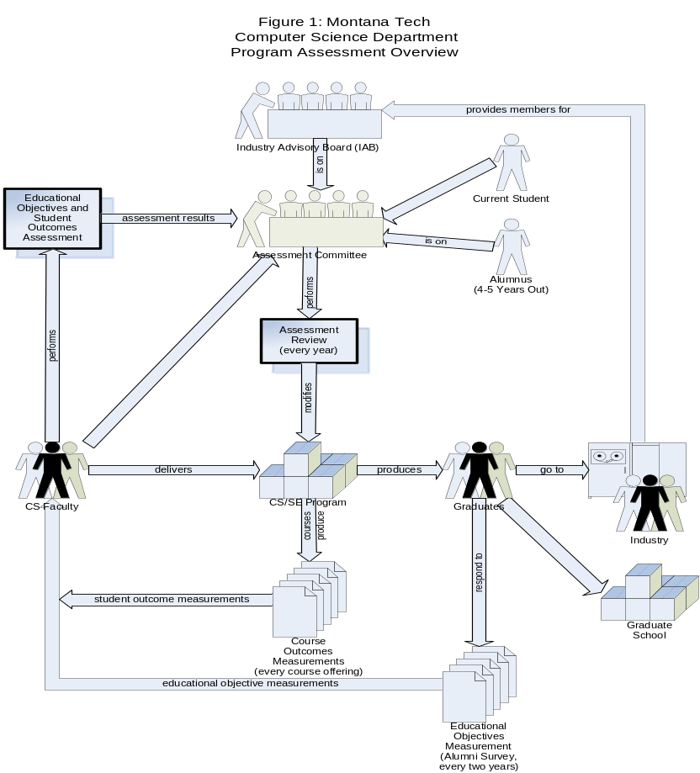

Appendix 1: Student Outcomes for CS and SE Programs

The CS and SE curricula outcomes are those defined by the ABET Computing Accreditation Commission and Engineering Accreditation Commission outcomes for the CS and SE programs respectively. These are on the web (http://cs.mtech.edu/main/index.php/component/content/article/146) and given below.

CAC: (Computer Science)
The program must enable students to attain, by the time of graduation:
(a) An ability to apply knowledge of computing and mathematics appropriate to the discipline
(b) An ability to analyze a problem, and identify and define the computing requirements appropriate to its solution
(c) An ability to design, implement, and evaluate a computer-based system, process, component, or program to meet desired needs
(d) An ability to function effectively on teams to accomplish a common goal
(e) An understanding of professional, ethical, legal, security and social issues and responsibilities
(f) An ability to communicate effectively with a range of audiences
(g) An ability to analyze the local and global impact of computing on individuals, organizations, and society
(h) Recognition of the need for and an ability to engage in continuing professional development
(i) An ability to use current techniques, skills, and tools necessary for computing practice.
(j) An ability to apply mathematical foundations, algorithmic principles, and computer science theory in the modeling and design of computer-based systems in a way that demonstrates comprehension of the tradeoffs involved in design choices. [CS]
(k) An ability to apply design and development principles in the construction of software systems of varying complexity. [CS]

EAC: (Software Engineering)
Engineering programs must demonstrate that their students attain the following outcomes:
(a) an ability to apply knowledge of mathematics, science, and engineering
(b) an ability to design and conduct experiments, as well as to analyze and interpret data
(c) an ability to design a system, component, or process to meet desired needs within realistic constraints such as economic, environmental, social, political, ethical, health and safety, manufacturability, and sustainability
(d) an ability to function on multidisciplinary teams
(e) an ability to identify, formulate, and solve engineering problems
(f) an understanding of professional and ethical responsibility
(g) an ability to communicate effectively
(h) the broad education necessary to understand the impact of engineering solutions in a global, economic, environmental, and societal context
(i) a recognition of the need for, and an ability to engage in life-long learning
(j) a knowledge of contemporary issues
(k) an ability to use the techniques, skills, and modern engineering tools necessary for engineering practice.

The program must demonstrate that graduates have: (SEC-1) the ability to analyze, design, verify, validate, implement, apply, and maintain software systems; (SEC-2) the ability to appropriately apply discrete mathematics, probability and statistics, and relevant topics in computer science and supporting disciplines to complex software systems; (SEC-3) the ability to work in one or more significant application domains; and (SEC-4) the ability to manage the development of software systems.

Appendix 2: Sample Course Outcomes

Outcomes for all of our courses are listed on the web at
http://cs.mtech.edu/main/index.php/component/content/article/146. Course outcomes for CSCI 332, Design and Analysis of Algorithms, are given below as an example. For each course outcome, the related student outcomes are given in parentheses.

R1. Students have implemented advanced data structures (hash table, balanced search tree, and a graph) using OOP design in a high level programming language and used them in simple programs. (CAC-c, i, j, k; EAC-e, k, 1)
R2. Students can perform in depth algorithm analysis, including average case efficiencies and Ω and Θ asymptotic notations. (CAC-a, b, j; EAC-a, e,1)
R3. Students know how to solve recurrences and use the Master Theorem to analyze Divide and Conquer algorithms. (CAC-a, b, j; EAC-a, e, 1)
R4. Students understand different algorithm design techniques (Brute Force, Divide and Conquer, Decrease and Conquer, Greedy, Dynamic Programming). (CAC-a, c, j; EAC-a, e,1)
R5. Students can prove the correctness of an algorithm. (CAC-a, j; EAC-a)
R6. Students understand algorithms that solve the classic problems, such as sorting, knapsack, string processing, matrix multiplication, spanning trees, shortest paths, traveling salesperson, and Huffman coding. (CAC-a, c, j; EAC-a, e,1)
R7. Students can identify and understand why some problems cannot be solved efficiently (NP problems). (CAC-a, c, j; EAC-a, e,1)

Appendix 3: Student Outcome Course Matrix

The following matrix show which courses contribute to the coverage of each student outcome. This is given on the web at http://cs.mtech.edu/main/images/assessment/se_cs_matrix%202.pdf

 | Software Engineering Student Outcomes
Courses | EAC-a | EAC-b | EAC-c | EAC-d | EAC-e | EAC-f | EAC-g | EAC-h | EAC-i | EAC-j | EAC-k | EAC-1 | EAC-2 | EAC-3 | EAC-4
CSCI 194 |  |  |  |  |  |  | X |  | X
CSCI 135 |  |  | X |  |  |  |  |  |  |  | X
CSCI 136 |  |  | X |  |  |  |  |  |  |  | X | X
CSCI 232 | X | X | X |  | X | X |  |  |  | X | X | X
CSCI 246 | X |  |  |  |  |  |  |  |  |  |  | X | X
CSCI 255 | X |  | X |  | X |  |  |  |  |  | X | X |  | X
CSCI 305 | X |  | X |  | X |  |  |  | X |  | X | X | X
CSCI 332 | X |  |  |  | X |  |  |  |  |  | X | X
CSCI 340 | X | X | X | X | X | X | X | X | X | X | X | X | X | X | X
CSCI 361 | X |  | X |  | X |  | X |  | X | X |  | X
CSCI 443 |  | X | X |  | X |  | X | X |  | X | X | X
CSCI 460 | X |  |  |  | X | X | X |  | X |  | X | X
CSCI 466 | X |  |  |  | X |  | X |  |  |  | X | X | X
CSCI 470 | X | X | X |  | X |  |  |  |  |  | X | X
CSCI 494 |  |  |  |  |  | X | X |  | X | X
ESOF 322 | X |  | X |  | X | X |  |  |  |  | X | X | X
ESOF 326 | X |  | X | X | X | X | X |  | X |  | X | X | X | X | X
ESOF 328 | X |  |  |  | X |  | X |  |  |  | X | X | X
ESOF 427 | X |  | X |  | X |  | X | X |  |  | X | X | X | X
ESOF 486/7 | X |  | X |  | X | X | X |  | X |  | X | X | X | X | X

 | Computer Science Student Outcomes
Courses | CAC-a | CAC-b | CAC-c | CAC-d | CAC-e | CAC-f | CAC-g | CAC-h | CAC-i | CAC-j | CAC-k
CSCI 194 |  |  |  |  |  | X |  | X
CSCI 135 |  | X | X |  |  |  |  |  | X | X | X
CSCI 136 |  | X | X |  | X | X |  |  |  |  | X
CSCI 232 | X | X | X |  | X |  |  |  | X | X | X
CSCI 246 | X
CSCI 255 | X |  | X |  |  |  |  |  | X |  | X
CSCI 305 | X |  | X |  |  |  |  | X | X | X | X
CSCI 332 | X | X | X |  |  |  |  |  | X | X | X
CSCI 340 | X | X | X | X | X | X | X | X | X | x | X
CSCI 361 | X |  | X |  |  | X |  | X | X | X | X
CSCI 438 | X | X |  |  |  |  |  |  | X | X
CSCI 446 | X | X | X |  | X |  | X | X |  | X
CSCI 460 | X |  | X |  |  |  |  | X | X | X | X
CSCI 466 | X |  |  |  |  | X |  |  | X | X | X
CSCI 470 | X |  | X |  |  |  |  |  | X | X | X
CSCI 486 | X | X | X |  |  |  |  | X | X | X | X
CSCI 494 |  |  |  |  | X | X |  | X
CSCI 498 | X |  |  | X |  | X |  | X | X |  | X
ESOF 322 | X |  | X |  | X | X |  |  | X |  | X
ESOF 326 | X | X | X | X | X | X | X | X | X | X | X

For ease of cross-reference the course numbers and their corresponding course titles are listed below:

Course Numbers and Titles:
CSCI 135: Fundamentals of Computer Science I
CSCI 136: Fundamentals of Computer Science II
CSCI 194: Computer Science and Software Engineering Freshman Seminar
CSCI 232: Data Structures and Algorithms
CSCI 246: Discrete Structures
CSCI 255: Introduction to Embedded Systems
CSCI 305: Concepts of Programming Languages
CSCI 332: Design and Analysis of Algorithms
CSCI 340: Database Design
CSCI 361: Computer Architecture
CSCI 438: Theory of Computation
CSCI 443: User-Interface Design
CSCI 446: Artificial Intelligence
CSCI 460: Operating Systems
CSCI 466: Networks
CSCI 470: Web Science
CSCI 494: Senior Seminar
CSCI 498: Internship
ESOF 325: Software Engineering
ESOF 326: Software Maintenance
ESOF 328: Requirements and Specifications
ESOF 427: Software Design and Architecture
ESOF 486: Senior Design Project I
ESOF 487: Senior Design Project II

Appendix 4: Course Outcome Review and Evaluation Report

A CORE report for CSCI 332, Design and Analysis of Algorithms, is given as an example below. The CORE template is given on the web at http://cs.mtech.edu/main/index.php?option=com_content&view=article&id=74.

Montana Tech of the University of Montana
Computer Science Department
Course / Program Outcome Assessment Form

Version: 2009-5

Course #: | CSCI 332 | Course Title: | Design and Analysis of Algorithms
Instructor: | Jeff Braun |  | Semester: | Spring 2011

Part I – To be completed before the semester begins.
Date: 1/15/11

Enrollment: 6

Course Description

Uses and reinforces basic data structure knowledge and techniques from Data Structures and Algorithms I (CSCI 232). Covers several advanced data structures, including balanced search trees and graphs. Studies common algorithm design methods (Brute Force, Decrease and Conquer, Divide and Conquer, Greedy, and Dynamic Programming) to solve various classic problems. Emphasizes the space and time complexities of various data structures and their associated algorithms.

Modifications made to course with respect to previous year (copied from last year’s form is you taught the course last year):

- Have the students do more program design.
- Emphasize and state important topics that will be on the tests and final exam.
- Allow more time in class for students to work examples and trace algorithms.

Course Outcomes with Related Program Outcomes

Expectations:

E1. Students know how to program in C++. (CSCI 232)
E2. Students understand basic data structures like lists, sorted lists, stacks, and queues and can evaluate the best data structure to implement them. (CSCI 232)
E3. Students understand and can use general trees, binary trees, binary search trees, and balanced search trees, tables, priority queues, heaps, hash tables, and graphs. (CSCI 232)
E4. Students understand space and time efficiency (Big O notation) of data structures and algorithms. (CSCI 232)
E5. Students are able to use inference and to develop direct and inductive proofs, proofs by construction, and proofs by contradiction. (CSCI 246)

Course Outcomes:

R1. Students have implemented advanced data structures (hash table, balanced search tree, and/or a graph) using OOP design in a high level programming language and used them in simple programs. (CAC-c,i,j,k; EAC-e,k,1)

R2. Students can perform in depth algorithm analysis, including average case efficiencies and Ω and Θ asymptotic notations. (CAC-a,b,j; EAC-a,e,1)

R3. Students know how to solve recurrences and use the Master Theorem to analyze Divide and Conquer algorithms. (CAC-a,b,j; EAC-a,e,1)

R4. Students understand different algorithm design techniques (Brute Force, Divide and Conquer, Decrease and Conquer, Greedy, Dynamic Programming (CAC-a,c,j; EAC-a,e,1)

R5. Students can prove the correctness of an algorithm. (CAC-a,j; EAC-a)

R6. Students understand algorithms that solve classic problems, such as: sorting, knapsack, string processing, matrix multiplication, spanning trees, shortest paths, traveling salesperson, Huffman coding. (CAC-a,c,j; EAC-a,e,1)

R7. Students can identify and understand why some problems cannot be solved efficiently (NP problems). (CAC-a,c,j; EAC-a,e,1)

Related Program Outcomes from Program Course Outcome Matrix

CAC-a, b, c, i, j, k
EAC – a, e, k, 1

Student Feedback (from previous offering)

The average evaluation scores range from 4.0 to 4.8. I still need to work on clearly stating the objectives of every class and making it easier for students to outline my lectures.
Part II – To be completed and turned into the Computer Science/Math Administrative Associate within two weeks of the class being over.

Date: 5/27/11

Number of students completing the course: 6

At the end of the semester, what was your course grade distribution?
Please put the number of students, not a percentage

___2___ A ___2___ B ___1___ C _______ D ___1___ F _______I _______W

At the beginning of the semester, what portion of the students in the class were competent in most of the prerequisite material? (Mark one response)

    >90%   80-89%   70-79%   60-69%   <60%

What lacking prerequisite-specific knowledge, if any, caused the most difficulty?

Math skills (logs, exponents) were weak for some students. One particular student that struggled failed Calculus II for at least the second time.

What general skills and abilities were weaker than expected at this stage of your students’ education?

Students do not retain what is taught in math courses and discrete structures (logs, derivatives, combinations, permutations, etc.).

Can you suggest any changes in prerequisite courses or their contents that would better prepare students for the class?

THE PROGRAM OUTCOMES IDENTIFIED IN YOUR SYLLABUS COURSE OUTCOMES ARE LISTED BELOW. PLEASE IDENTIFY THE PERCENTAGE OF STUDENTS WHO SHOWED EVIDENCE THAT THEY MET THE REQUIREMENTS OF THIS OUTCOME.
OUTCOME / DESCRIPTION |  | MEASURE | PERFORMANCE TO MEET OUTCOME | % MET OUTCOME
CAC-a  CAC-b  CAC-c  CAC-i  CAC-j  CAC-k  EAC-a  EAC-e  EAC-k  SEC-1 | An ability to apply knowledge of computing and mathematics appropriate to the discipline.  An ability to analyze a problem, and identify and define the computing requirements appropriate to its solution.  An ability to design, implement and evaluate a computer-based system, process, component, or program to meet desired needs.  An ability to use current techniques, skills, and tools necessary for computing practice.  An ability to apply mathematical foundations, algorithmic principles, and computer science theory in the modeling and design of computer-based systems in a way that demonstrates comprehension of the tradeoffs involved in design choices.  An ability to apply design and development principles in the construction of software systems of varying complexity.  An ability to apply knowledge of mathematics, science, and engineering.  An ability to identify, formulate and solve engineering problems.  An ability to use the techniques, skills, and modern engineering tools necessary for engineering practice.  The ability to analyze, design, verify, validate, implement, apply, and maintain software systems. | Final Exam #1, 2, 11, 13d  Final Exam #2, 11, 13d  Program 5&7  Program 5&7  Final Exam #1, 2, 4, 5, 7, 9, 11  Program 5&7  Program 5&7  Final Exam #1, 2, 11, 13d  Final Exam #1, 2, 4, 5, 7, 9, 11  Prog. 5&7  Program 5&7  Final 1, 2, 7, 9, 11  Program 5&7 | 70% is 34 out of 49 points  70% is 24 out of 34 points  70% is 76 out of 108 points  70% is 76 out of 108 points  70% is 152 out of 217 points  70% is 76 out of 108 points  70% is 34 out of 49 points  70% is 152 out of 217 points  70% is 76 out of 108 points  70% is 126 out of 180 points | 50%  50%  83%  83%  67%  83%  50%  67%  83%  83%

Are there any other comments you would like to add for the assessment committee?

None

Anticipated improvements to the course:

- Have the students do more program design earlier in the semester.
- Allow more time in class for students to work examples and trace algorithms.

Proposed new course expectations and outcomes:

None

Proposed changes to the catalog description (show the original along with changes):

None

Reflections and lessons learned:

Students only turned in a design for the last program. I supplied UML designs for the first several programs. I expect many students designed at the terminal as they coded.

Emphasizing what would be on the tests helped students better prepare for the exams, though some students still ignored/missed these major points.

Appendix 5: Educational Objectives

Objectives are statements that describe the expected accomplishments of graduates during the first three to five years after graduation. The CS and SE programs have the following educational objectives. These can be found on the web at
http://cs.mtech.edu/main/index.php/component/content/article/145.

Graduates of the Computer Science program will have:
1. adapted, thrived and contributed in an industry setting or completed a graduate program;
2. contributed to the continual improvement and competitiveness of their workplace;
3. demonstrated an ongoing commitment to professional development.

Graduates of the Software Engineering program will have:
1. adapted, thrived and contributed in an industry setting or completed a graduate program;
2. contributed to improved software quality and the state of the art by promoting the adoption of best practices and supporting those best practices that are already being used;
3. demonstrated an ongoing commitment to professional development.

